Rand

Public School

Revised 6th February, 2025

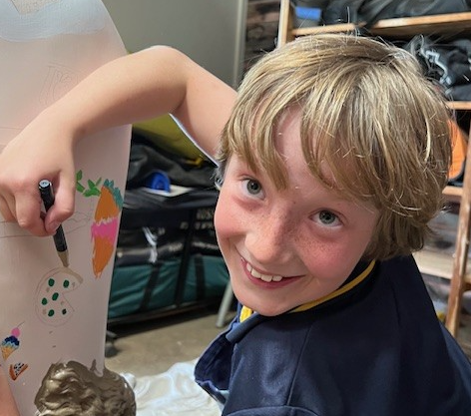

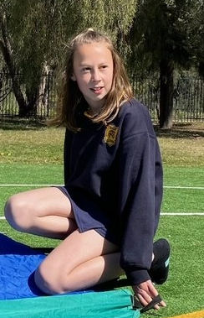

School Behaviour Support & Management Plan

**CONTENTS**

* Overview
* NSW Education Behaviour Code for students
* Rand Public School Rules and Expectations

* Promoting and reinforcing positive student behaviour
  + - Proactive and restorative practices
    - Care continuum
    - Classroom management
    - School community charter
* Strategies and Systems at Rand Public School
  + - Whole School Approach
    - Detention, reflection and restorative practices
    - Rand Public School Anti-bullying Plan
* Review
* Appendix
  + - Rand Public School behaviour flowchart
    - Rand Public School classroom posters
    - Ready to Learn Plan (template)
    - Positive Behaviour For Learning Visuals
    - Incident Recording Form
    - Level 2 Letter (template)
    - Behaviour Card (template)
    - Level 3 Letter (template)
    - Behaviour Management Plan (template)
    - Department of Education Document Links

The strategies and procedures in this document support the NSW Department of Education Student Behaviour Policy (PD-2006-0316-06-Vo2.0.0) which is effective as of Monday, October 10th 2022

and applies to:

* *All NSW Government Schools*
* *Student behaviour*
  + *At school*
  + *On the way to and from school*
  + *On school-endorsed activities that are off-site*
  + *Outside school hours and off school premises where there is a clear and close connection between the student’s behaviour and the student’s conduct.*
  + *If the student’s conduct significantly affects, or is likely to affect, the health, learning and safety of students or staff.*
  + *When using social networking sites, mobile devices or any other technology involving another student or a departmental staff member for school related issues.*



* *Principals acting in accordance with the Student Behaviour Policy*

**OVERVIEW**

Rand Public School is committed to explicitly teaching and modelling positive behaviour and to supporting all students to be engaged with their learning. We are committed to providing a safe, supportive and responsive learning environment for everyone. We teach and model the behaviours we value in our students. Our school takes strong action in response to bullying, violent, intimidating or discriminatory behaviours that cause hurt or harm to any member of the school community.

Every student has the right to an education. They have the right to connect, thrive and survive. To enable staff to create inclusive, engaging and respectful school, some circumstances exist where behavioural interventions are necessary. The principal, teachers and school staff will seek to understand and support each student’s individual needs. They will respond accordingly to individual circumstances and the reasons for student behaviour.

***Compliance Documents:*** *Student Behaviour Strategy, Behaviour Code for Students, School Community Charter, Detention and Time Out*

*Guidelines, Preventing and Responding to Student Bullying: Prevention and Response, Student Welfare Policy*.

***Rand Public School will be an inclusive school where all students:***

* Can learn new skills
* Lean how to behave in positive ways at different times, in different places and with different people
* Learn to connect positively with others.
* Have good, positive learning experiences
* Stay safe and healthy.
* Take part in the school and the community
* Speak up for themselves
* Engage in discussions about their learning

***Every member of the school community will contribute to the school’s positive, inclusive culture and support behaviour expectations by:***

**PRINCIPAL**

* Ensuring that all staff follow the policy (PD-2006-0316-06-V02.0.0, effective as of 10th October 2022)
* Seeking support for students when necessary
* Ensuring that the school is inclusive
* Writing, and annually reviewing, the school plan for behaviour supports.
* Sharing the school plan with the community
* Providing staff with professional learning to support the school’s behaviour plan
* Supporting staff to develop and implement behaviour management strategies
* Intervening when student behaviour places others at risk.
* Complying with NSW Department of Education guidelines
* Allowing students, parents and carers to make appeals or complaints.
* Keeping accurate records of all occurrences related to the behaviour strategy policy.

**TEACHERS**

* Supporting plans for students to have good learning experiences and stay healthy.
* Being inclusive
* Explicitly teaching expected behaviours
* Engaging in professional learning to allow them to do their job well
* Dealing with behaviours of concern
* Creating, implementing and reviewing plans to support students to behave in positive ways.
* Ensuring behaviour expectations in the school are consistent
* Supporting students to meet high behaviour expectations

**PARENTS & CARERS**

* Working with the school to support their child(ren)’s learning
* Working with the school to support their child(ren)’s behaviour
* Supporting the school’s plan to manage how students behave
* Communicating with the staff when out-of-school circumstances may influence behaviour
* Collaborating with the school when there are issues with how their child(ren) behave.

**STUDENTS**

* Being aware of the school’s behaviour expectations
* Actively engaging in learning opportunities that enhance their wellbeing
* Following the NSW Public Education Code of Behaviour for Students.

**RAND PUBLIC SCHOOL RULES AND EXPECTATIONS**



**Our Rules:**

* ***I will give my best effort at all times***
* ***I will be respectful***
* ***I will be kind***

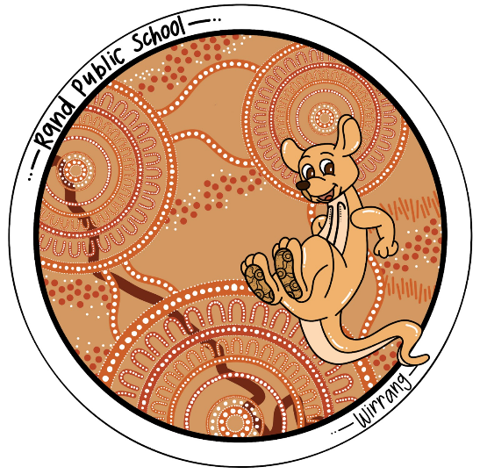

**Our Expectations:**

**Best Effort**

* **Be an active participant**
* **Right place, right time**
* **Persevere and keep trying**

**Respect**

* **Listen to the person who is speaking**
* **Follow instructions**
* **Care for belongings, equipment and the environment**
* **Keep hands, feet and objects to yourself**

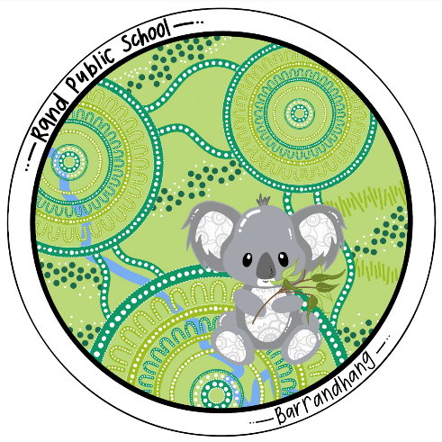**Kindness**

* **Kind words, kind actions**
* **Include others**
* **Lend a hand**

### PROMOTING AND REINFORCING POSITIVE STUDENT BEHAVIOUR AND SCHOOL-WIDE EXPECTATIONS Proactive and Restorative Strategies

**Proactive and Restorative Strategies**

Rand Public School will use behaviour supports to:

* Helps students plan positive ways to behave
* Identify which students are at risk of not behaving in positive ways
* Plan for students who show behaviours of concern
  + Behaviours that may put themselves or others in danger
  + Challenging, complex or unsafe behaviours that require persistent of intensive interventions
  + Does NOT include low level, developmentally appropriate behaviours.

**The school will embed preventative and responsive strategies to best support the behaviour of all students.**

**Preventative strategies** **are proactive and encourage students to be on-task, motivated to learn and prosocial. The effective strategies used at Rand Public School include:**

* Icon

  Description automatically generatedcreating and maintaining a positive classroom environment
* using structured instruction to engage students in learning
* explicitly teaching students rules and routines
* offering pre-corrections to remind student of expectations
* using active supervision in the classroom

**Responsive strategies** **include corrective responses to inappropriate behaviours. They support students to re-engage in learning. At Rand Public school, the effective strategies in use include:**

* Icon

  Description automatically generatedidentifying why a student is disruptive or disengaged
* ensuring that the student understands the corrective response
* expected and consistent responses
* calm interaction with, and directions to, students
* ensuring correction is proportionate to the behaviour displayed.

**The Care Continuum**

Students may require different types of intervention delivered in different ways along a continuum of need to be best meet their needs. This is called the care continuum and it will be applied at Rand Public School.

The care continuum includes interventions for:

* Diagram

  Description automatically generatedall students – creating a safe and respectful learning environment
* some students – providing early intervention and targeted support

for students at risk of developing negative behaviours.

* A few students – supporting students with complex and challenging

behaviour needs through intense, individual interventions.

The care continuum is supported by effective classroom management strategies and practices.

**Classroom Management**

Classroom management refers to the strategies that teachers use to support and facilitate learning in the classroom. Effective classroom management is important for student achievement because it creates an environment that minimises disruptions, maximises instruction time, and encourages students to engage in learning.

Classroom management requires both preventative and responsive strategies, with an emphasis on preventative strategies.

|  |  |
| --- | --- |
| Classroom Management for  **all** students | ~ Strong teacher/student relationships  ~ Explicit teaching and modelling of behaviour expectations  ~ Explicit teaching and modelling of social skills  ~ Communication with parents around school expectations  ~ School-based systems of expectations and positive reinforcement  ~ Consistent teacher expectations, routines, modelling and response to behaviour  ~ Inclusion of taking turn activities into classrooms and playground (eg: board games)  ~ Social skills programs and lessons  ~ High quality, differentiated teaching  ~ A restorative approach that focuses on building and maintaining positive relationships.  ~ Implementation on the Berry Street Education Model   * + mindfulness and brain breaks   + social/emotional learning programs   + ready to learn plans |
| Classroom Management for  **all or some** students | ~ Effective communication with parents, including communication books  ~ Explicit teaching and modeling of specific skills and behaviour expectations  ~ Restorative practices and circle time  ~ Self-regulation training – brain breaks, yoga, heavy work, weighted blankets |
| Classroom Management for  **some** students | ~ Communication books with parents  ~ Sensory supports  ~ modified expectations and goals  ~ transition strategies and explicit teaching (eg: class to playground, lesson to lesson) |
| Classroom Management for **individual** students | ~ Daily communication with parents  ~ Check in/check out  ~ Sensory assessment and supports  ~ negotiated playground programs  ~ Individualised programs to teach competence, inter-personal skills and social-emotional regulation |

**School Community Charter**

The school will meet the school community charter by fostering an environment and culture that is collaborative, supportive and cohesive.



RAND PUBLIC SCHOOL USES THE FOLLOWING STRATEGIES AND SYSTEMS TO EXPLICITLY TEACH, RECOGNISE AND REINFORCE POSITIVE BEHAVIOUR AND BEHAVIOURAL EXPECTATIONS:

### Whole School Approach

|  |  |  |  |
| --- | --- | --- | --- |
| Care Continuum | Strategy or Program | Details | Audience |
| Prevention | Berry Street Education Model  (BSEM) | ~ The Berry Street Education Model provides strategies that enable teachers to increase engagement of students to improve self-regulation, relationships, wellbeing and academic growth. BSEM has 5 levels of learning that support the school and includes:   * mindfulness & brain breaks * de-escalation strategies * personalised learning plans and interventions * positive relationship building and maintenance. * Identifying and responding to emotions * Consistent language and practices | Whole school |
| Prevention | Behaviour Code for students - setting high and explicit expectations | ~ All students revise the behaviour code with teaching staff  ~ School rules and expectations are explicitly taught  ~ Expectations are displayed for all students (with visuals)  ~ Class expectations are displayed in all classrooms. | K-6 students  Families  Teaching Staff  Non-Teaching staff |
| Prevention | Bluearth | Bluearth is a movement and mindfulness program focused on team work, resilience, problem solving and self-umpiring. | Whole school |
| Prevention | School Programs and Activities | ~ The school has a range of embedded programs and  practices that support positive behaviour choices and the  development of social skills   * Peer Support * Student leadership * Student recognition (eg: awards, reports) * Student Learning support Officers | Whole school |
| Prevention | Positive Behaviour for Learning – Tier 1 | ~ School-wide and classroom systems of support that  contributes to the development of a positive, safe and  supportive learning culture through:   * Clearly defined behaviour expectations * Explicit teaching of expected behaviours * Timely, appropriate responses to problem behaviour * Active encouragement of expected behaviours * Regular data review and monitoring * Effective, consistent classroom practice * A planned, intrinsic and extrinsic reward system | Whole school |
| Targeted Intervention | Positive Behaviour for Learning – Tier 2 | ~ Classroom and playground systems of support that  some students to regulate their own behaviour   * Ready-to-learn plans * Behaviour management support plans * De-escalation plans * Sensory supports | Identified students |
| Individual Intervention | Positive Behaviour for Learning – Tier 3 | ~ Classroom and playground systems of support that  some students to regulate their own behaviour   * Behaviour Contracts * Behaviour Response plans * Behaviour management support plans * Sensory supports * External service provider intervention (eg Intereach) | Identified students |

### Detention, reflection and restorative practices

|  |  |  |  |
| --- | --- | --- | --- |
| Action | When and how long? | Who coordinates? | How are these recorded? |
| Calming Corner | Maximum of 10 minutes – opportunity for students to re-set in a calm space with sensory supports provided. | Teaching staff | - |
| Level 1 Time out | Maximum 10 minutes -on the day of the inappropriate behaviour | Teaching staff | Time out register in Rand PS Teams |
| Alterative learning space (Level 2) | Immediately after a student reaches level 2 – remain there until the end of the learning session | Teaching staff | Level register in Rand PS Teams |
| Restorative conversation | As soon as possible after the inappropriate behaviour | Staff involved in the incident | Rand PS Behaviour Records folder in TEAMS |
| Incident Report | Immediately after the inappropriate behaviour | Teaching staff |
| Level 2 Behaviour Card | 3 days – immediately after the inappropriate behaviour | Principal |
| Level 3 Behaviour Card | 5 days – immediately after the inappropriate behaviour | Principal |
| Individual Behaviour Support Plan | Immediately after the identification of need – the plan will support the development of specific behaviour goals for individuals and identify strategies to support students. These plans will be reviewed every 5 weeks | Teaching staff  – in collaboration with the student’s parents/carer | Rand PS Behaviour Records folder in TEAMS and EBS |
| De-escalation plan | As soon as possible after and incident where a student is heightened – this plan will detail student escalation behaviours and the responses that will be taught to reduce the incidence of inappropriate behaviour | Principal – in collaboration with teaching staff and the student’s parents/carer |
| Behaviour Contract | After de-escalation – the contract is a positive reinforcement intervention that details the expectations of staff, the student and parents to support positive behaviours | Teaching staff  – in collaboration with the student’s parents/carer |
| Behaviour Response Plan | Immediately - to be used when a student’s behaviour escalates to a crisis point and interferes with the safety of the staff, the students themselves and those around them. The plan will guide the actions of others to reduce the stress of the individual and keep everyone safe. | Principal – in collaboration with teaching staff and the student’s parents/carer givers. |
| Critical Incident Report | Within 24 hours of an incident (1800 811 523) | Principal | EBS |
| Formal Caution | Within 24 hours of an incident  ~ school must clearly explain how the student’s  actions put themselves and/or others in danger  ~ must include a date for parent/student/school  meeting | Principal |
| Suspension | ONLY after all other processes have been implemented and the principal believes that the student poses harm to themselves or others. Suspension must be approved by the Director, Educational Leadership and the Behaviour strategy Team  ~ K-2 students: up to 5 days  ~ 3 -6 students: up to 10 days  ~ No more than 3 suspension a year for a student  ~ Parents will be notified within 24 hours  ~ A support plan developed to return to school | Principal – in collaboration with teaching staff and the student’s parents/carer givers.  Support personnel as required (eg :school counsellor, Assistant Principal Learning) |

### REVIEW

The School Excellence Framework v2 makes explicit effective learning, teaching and leadership practices that support a quality learning environment for all students. It is the basis for evaluating the impact and effectiveness of our interventions and strategies to support student wellbeing and a quality learning environment.

Rand Public School will review the School Behaviour Support and Management Plan every 12 months, using the following data and information:

* Academic progress data
* Attendance data
* Suspension Data
* Behaviour Incident Records
* Parent Meeting minutes
* Updates to NSW Department of Education Policies

Any adjustments or modifications to the plan will be made in consultation with school staff and the Rand Public School Parents and Citizen’s Association

**Initial document date: 27th October 2022**

**Last review date: 16th February 2024**

**Next review date: February 2025**

**Rand Public School**

Behaviour Flowchart - Classroom

We are Kind, Respectful and Give our Best Effort

|  |  |  |  |
| --- | --- | --- | --- |
| STEP | VISUAL | SCRIPT | ACTIONS |
| **1**  Warning |  | **Student is not complying with an instruction, or has behaved inappropriately:**  *At Rand Public School, we are kind, respectful, give our best effort (choose appropriate). I need you to…..*  Behaviours that may result in warning:   * Off task * Refusal to participate * Unsafe play * Unsafe behaviour * Disregarding staff instructions * Isolated bullying comments / actions * Walking away from an adult * Leaving the classroom/learning space without permission | Name on board  Redirect to desired behaviour |
| **2**  Strike 1 | Worried Emoticon | Funny emoticons, Animated smiley faces, Emoticon | **Student is not complying with an instruction, or has behaved inappropriately:**  *At Rand Public School, we are kind, respectful, give our best effort (choose appropriate).*  *You are now on Strike 1.*  *I need you to …*  *Give the student time (at least 1 minute) to process the request and respond* | Strike 1 – cross beside name/initials  Redirect to desired behaviour |
| **3**  Strike 2 | Emoticons | Funny emoji faces, Funny emoji, Emoticon | **Student is still not complying with an instruction, or has behaved inappropriately:**  *At Rand Public School, we are kind, respectful, give our best effort (choose appropriate).*  *You are now on Strike 2.*  *I need you to …*  *Give the student time (at least 1 minute) to process the request and respond* | Strike 2 – cross beside name/initials  Provide sensory supports if needed  Assess level of task difficulty  Redirect to desired behaviour |

|  |  |  |
| --- | --- | --- |
| STEP | BEHAVIOURS | ACTIONS |
| **4**  Strike 3  Free photo Sad Sad Face Unhappy Face Crying Emotions - Max Pixel**Level 1** | **Student is still not complying with an instruction, or has continued to behave inappropriately:**  *You have not shown respect and followed my instructions.*  *You are now on Level 1.*   * *I need you to go to the other classroom for 10 minutes of time out.* | Strike 3 – cross beside name/initials  Student to other class or office  10 minutes of time out of class  Learning to be completed in other class or at next break  Teacher to ring parents  Record on EBS / School Bytes |
| **5**  Level 2 | * Level 1 three times in a week * Swearing at an adult * Destroying property * Stealing * Physical violence without intent * Bullying * Aggressive defiance | Other class for the remainder of the session  Off the playground for 3 days  Behaviour card (home to parents each day)  Phone call to parents – teacher  Record on EBS / School Bytes |
| **6**  Level 3 | * Level 1 while on Level 2 * Failing to meet behaviour card expectations * Swearing with intent (at staff or students) * Persistent bullying * Physical violence with intent | Off the playground for 5 days  Behaviour card (home to parents each day)  Warning of suspension  Withdrawn from off-site activities  Principal to phone and/or meet with parents  Record on EBS / School Bytes |

### Rand Public School – Classroom posters for behaviour support

|  |  |
| --- | --- |
| Learning spaces at Rand Public School have posters to assist students with making positive behavioural choices as part of the proactive and restorative classroom management strategies.  Teaching staff and School Learning Support Officers (SLSOs) have these posters as visuals on lanyards to use with small groups or individuals to prompt positive choices. |  |
|  |  |
|  |  |

### 

### Rand Public School – Ready To Learn Plan

Each class (Wallaby and Koala) will have a ‘Ready To Learn Plan’ that is developed with staff to meet the needs of the majority of students and develop behaviour expectations.

Some students may have their own individual Ready To Learn plan

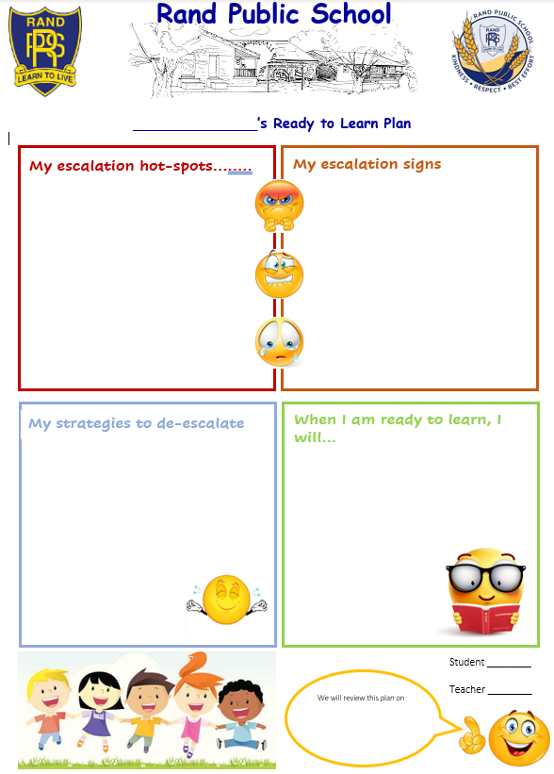

**Rand Public School**

### Rand Public School – Positive Behaviour For Learning Posters

|  |  |
| --- | --- |
| Students at Rand Public School receive explicit instruction on the school’s high expectation behaviours and their own responsibilities.  To support students to make positive choices, there are posters in target areas that include visuals to support all students.  These posters and their information are regularly reviewed at Monday Muster, in classrooms, and when a need is identified. |  |
|  |  |
|  |  |

**Rand Public School**

**Student Incident/Injury Report**

|  |  |  |
| --- | --- | --- |
| Report Type | **Incident** | **Injury** |
| STUDENT |  | |
| Date of Birth |  | |
| Date of Report |  | |
| Location |  | |
| Details |  | |
| Outcome |  | |
| Parent Contact |  | |
| Hotline Report | **Yes** | **No** |
| Hotline Receipt |  | |

Report Completed By……

|  |  |  |
| --- | --- | --- |
| Name |  | |
| Role |  | |
| Signed | | Date |

**Rand Public School – Level 2 Letter template**

**Rand Public School**

Date: ____ . ____ . _______

Dear ____________

This letter is to inform you that ______ behaviour at school today has been unacceptable.

_____ is now on a **Level 2** for _____ behaviour and will be on a **behaviour card for three days** which will be signed by a teacher every session. This will go home every day for you to sign as well.

Our school has a positive behaviour support approach which allows students to reconnect with their learning and school environment. _______ will be encouraged to identify behaviour triggers, appropriate responses, and accept responsibility for _____ choices in order to move forward.

The school will be in contact to arrange a meeting with you to discuss how we can support ___________ to make positive behaviour choices.

***At Rand Public School we value:***

* Kindness
* Respectful
* Giving our Best Effort

Today, _________ chose not to meet these values by:

* _______________________________________________

Please sign the form and return the form below to our office for our records.

Regards

Class teacher(s) Principal

Name: ________________

I/We have discussed the above matter with _______ and ________ understands the consequences.

Signature: _________________________ Date:____________________

### Rand Public School – Behaviour Card

### Rand Public School – Level 3 letter template

**Rand Public School**

Date: ___________________

**Rand Public School**

Dear ___________________

This letter is to inform you that _____________ behaviour at school over the last few days has been unacceptable and causing concern for our staff and students.

________ is now on a **Level 3** for _______ behaviour and will be off the playground and also on a **behaviour card for five days** which will be signed by a teacher every session. This will go home every day for you to sign as well.

Our school has a positive behaviour support approach which allows students to reconnect with their learning and school environment. __________ will be encouraged to identify behaviour triggers, appropriate responses and accept responsibility for ___________ choices in order to move forward.

The school will be in contact to arrange a meeting with you to discuss how we can support ___________ to make positive behaviour choices

If ______ continues this behaviour then ______ may be suspended in accordance with the procedure for the Department of Education and Communities Suspension and Expulsion of School Students. A copy of the Suspension and Expulsion of School Students Procedure is available on the Department's "Our Policies" website at the following address:

<https://education.nsw.gov.au/content/dam/main-education/policy-library/associated-documents/suspol_07.pdf>

***At Rand Public School we value:***

* Kindness
* Respectful
* Giving our Best Effort

Today, ___________ chose not to meet these values by:

Please sign the form and return the form below to our office for our records.

Regards

Class teachers Principal

Name:

I/We have discussed the above matter with _______________ and ___________ understands the consequences.

Signature: _________________________ Date:____________________

### NSW Department of Education – links to documents that support the Behaviour Strategy

* Student behaviour strategy <https://education.nsw.gov.au/student-wellbeing/attendance-behaviour-and-engagement/behaviour-strategy/the-student-behaviour-strategy>
* Behaviour Code for Students <https://education.nsw.gov.au/policy-library/policies/pd-2006-0316/pd-2006-0316-01>
* Detention and time out guidelines <https://education.nsw.gov.au/policy-library/policies/pd-2006-0316/pd-2006-0316-04>
* Student behaviour management and plan guide <https://education.nsw.gov.au/policy-library/policies/pd-2006-0316/pd-2006-0316-05>
* Student Behaviour Procedures Kindergarten to Year 12 <https://education.nsw.gov.au/policy-library/policies/pd-2006-0316/pd-2006-0316-06>
* School Community Charter <https://education.nsw.gov.au/content/dam/main-education/public-schools/going-to-a-public-school/media/documents/school-community-charter.pdf>
* Student Attendance Policy <https://education.nsw.gov.au/policy-library/policies/pd-2005-0259/student-attendance-in-government-schools-procedures-2015--docx-3>
* Student Welfare <https://education.nsw.gov.au/policy-library/policies/pd-2002-0052>
* School Excellence Framework <https://education.nsw.gov.au/content/dam/main-education/teaching-and-learning/school-excellence-and-accountability/media/documents/SEF_Document_Version_2_2017_AA.pdf>